Assignment 2 MCDM

1. You can select one of the listed scenarios and use any open-source MCDM software of your choice. You should start with the identification of appropriate criteria and sub-criteria for making a decision and you can make necessary assumptions as needed.

Assumption:

There was a company that needed an IT vendor. The company had specific criteria that they wanted the vendor to meet - Service Quality, Security, and Financial. There were four companies they were considering, each with their own strengths and weaknesses in these areas.

* Company A was known for their exceptional Service Quality and Security measures, but they were not very competitive in Financial. This is a common trade-off in the technology industry, where high-quality systems and infrastructure can come with a higher price tag.
* Company B, on the other hand, was the best in terms of Financial. They had competitive pricing that could potentially save the company money. However, they were only so-so in terms of Security. This can be a concern for businesses that rely heavily on their IT systems to run their operations smoothly.
* Company C was doing well in Financial, but they were only normal in Service Quality and Security measures. This could be a concern for businesses that need their IT systems to function at a high level to meet their customers' needs.
* Company D had not been mentioned yet, but they were the last option on the table. They were average in all three criteria, but not exceptional in any one area.

Whereas criteria & sub-criteria are as follows.

* Criteria 1: Service Quality
  + Sub-criteria 1: Responsiveness
  + Sub-criteria 2: Customer Satisfaction Record
  + Sub-criteria 3: SLA Compliance
* Criteria 2: Security
  + Sub-criteria 1: Data Security
  + Sub-criteria 2: Network Security
  + Sub-criteria 3: Confidentiality
* Criteria 3: Financial
  + Sub-criteria 1: Pricing & Costs
  + Sub-criteria 2: Payment Terms
  + Sub-criteria 3: Financial Stability

|  |  |  |  |  |  |
| --- | --- | --- | --- | --- | --- |
| Criteria | Sub-criteria | Company A | Company B | Company C | Company D |
| Service Quality | Responsiveness | 10 | 4 | 6 | 5 |
|  | Customer Satisfaction | 9 | 6 | 4 | 4 |
|  | SLA Compliance | 9 | 4 | 5 | 4 |
| Security | Data Security | 9 | 6 | 9 | 4 |
|  | Network Security | 7 | 6 | 7 | 7 |
|  | Confidentiality | 7 | 9 | 6 | 7 |
| Financial | Pricing & Costs | 3 | 7 | 8 | 9 |
|  | Payment Terms | 4 | 5 | 9 | 6 |
|  | Financial Stability | 6 | 10 | 6 | 5 |

2, You need to identify 4 choices and test your system to select the most suitable one. You need to submit a report to describe this system and how the system concludes the evaluation.

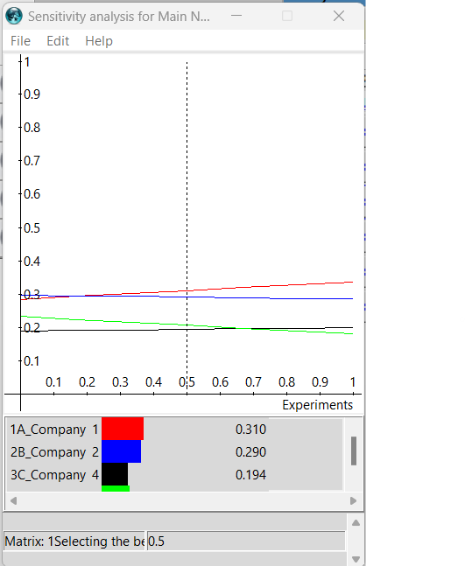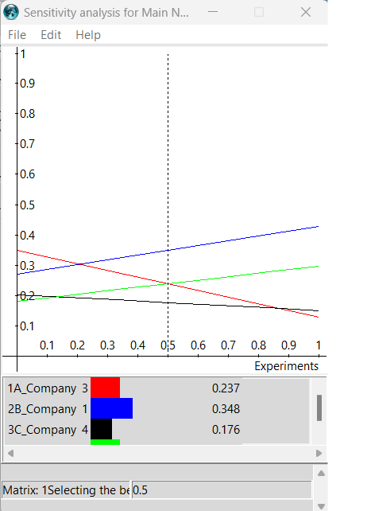

From Figure 1, Company A is the best followed with B respectively.

From Figure 2, Company A and B

From Figure 3,